ASSIGNMENT NO.5: Aggregate Functions and Data Analysis
Questions:
Q1) Create a MySQL database named CollegeDB and a table named StudentResult.
The table should contain the following columns:
Column Name | Data Type | Constraint
StudentID | INT PRIMARY | KEY
StudentName | VARCHAR(50)
Course | VARCHAR(30)
City | VARCHAR(30)
Marks | INT
FeesPaid | DECIMAL(10,2)
Insert at least 10 records into the table.

Query-
CREATE DATABASE CollegeDB;
USE CollegeDB;

CREATE TABLE StudentResult
(StudentID INT PRIMARY KEY,
StudentName VARCHAR(50),
Course VARCHAR(30),
City VARCHAR(30),
Marks INT,
FeesPaid DECIMAL(10,2)
);

INSERT INTO StudentResult
(StudentID, StudentName, Course, City, Marks, FeesPaid)
VALUES
(1, 'Aarav Sharma', 'B.Sc. Data Science', 'Pune', 85, 55000.00),
(2, 'Sneha Patil', 'B.Sc. Data Science', 'Mumbai', 78, 55000.00),
(3, 'Rahul Joshi', 'B.Sc. Data Science', 'Pune', 92, 55000.00),
(4, 'Priya Shah', 'BCA', 'Nashik', 74, 48000.00),
(5, 'Rohan Deshmukh', 'BCA', 'Pune', 81, 48000.00),
(6, 'Ananya Kulkarni', 'BCA', 'Mumbai', 69, 48000.00),
(7, 'Vikram Singh', 'BBA', 'Delhi', 88, 45000.00),
(8, 'Isha Mehta', 'BBA', 'Pune', 76, 45000.00),
(9, 'Karan Verma', 'B.Com', 'Mumbai', 64, 42000.00),
(10, 'Neha Gupta', 'B.Com', 'Pune', 91, 42000.00);

Output-
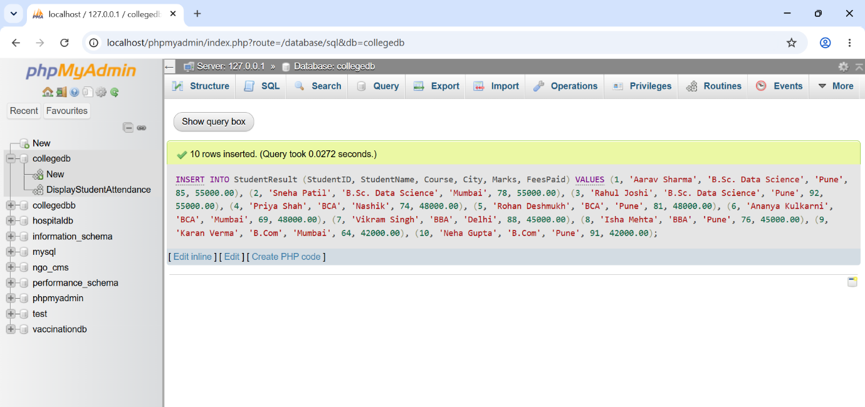

Q2) Write MySQL queries to find the following from the StudentResult table:
Requirement
Total number of students
Total fees paid
Average marks
Lowest marks
Highest marks

Query-
SELECT COUNT(*) AS TotalStudents
FROM StudentResult;

SELECT SUM(FeesPaid) AS TotalFeesPaid
FROM StudentResult;

SELECT AVG(Marks) AS AverageMarks
FROM StudentResult;

SELECT MIN(Marks) AS LowestMarks
FROM StudentResult;

SELECT MAX(Marks) AS HighestMarks
FROM StudentResult;

Output-
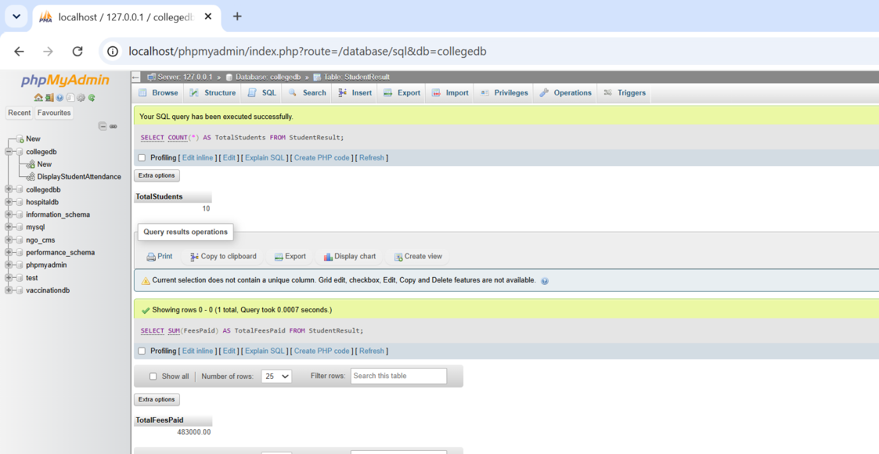
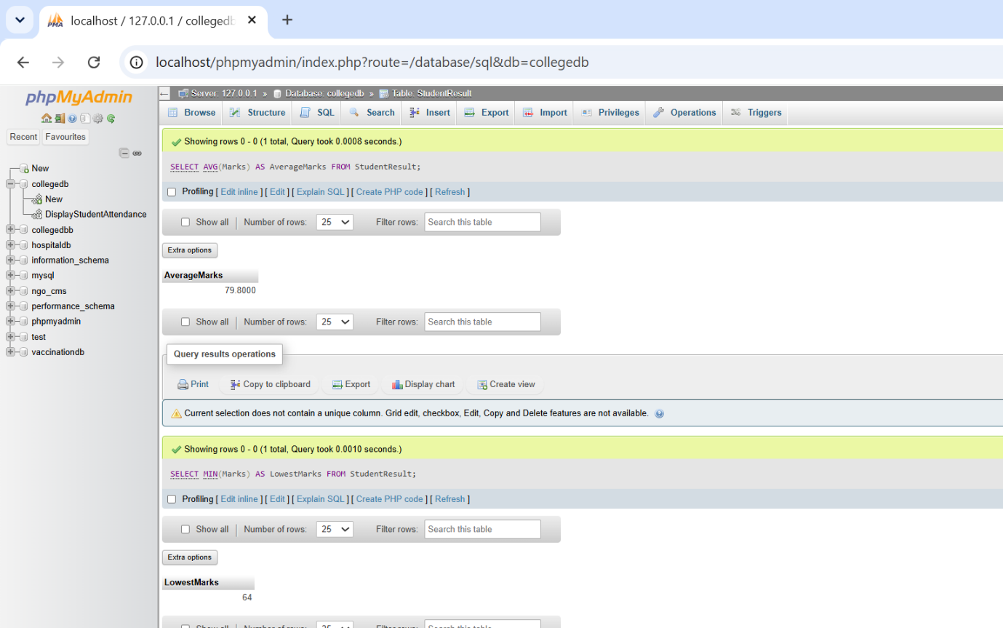


Q3) Write a MySQL query to count the number of students in each course.
The output should contain:
Column
Course
TotalStudents

Query-
SELECT COURSE, COUNT(*) AS TotalStudents
FROM studentresult
GROUP BY course;

Output-
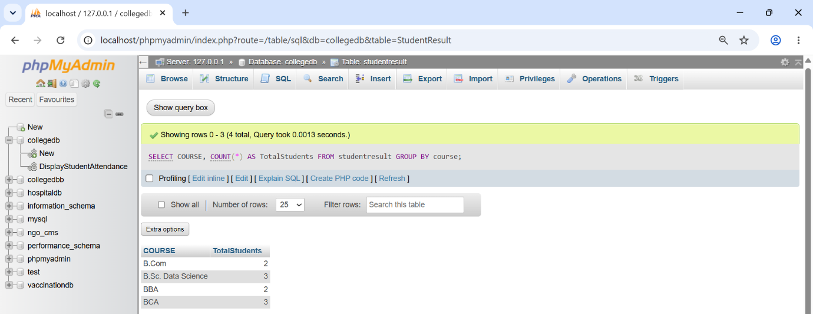

Q4) Write a MySQL query to find the average marks of students course-wise.
The output should contain:
Column
Course
AverageMarks

Query-
SELECT course, AVG(Marks) AS AverageMarks
FROM StudentResult
GROUP BY course;

Output-


Q5) Write a MySQL query to display only those courses where the number of students is
greater than 2.
Use:
Clause
GROUP BY
HAVING

Query-
SELECT Course, COUNT(*) AS TotalStudents
FROM StudentResult
GROUP BY course
HAVING COUNT(*) >2;

Output-
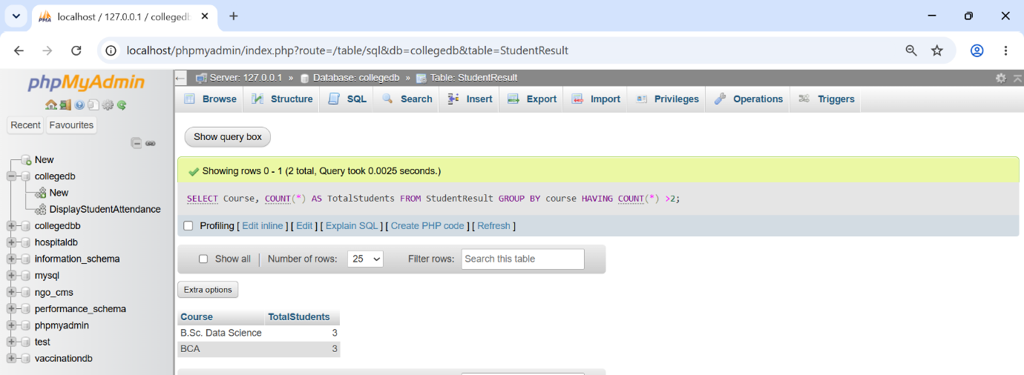

Q6) Write a MySQL query to analyze course performance.
The output should display:
Column
Course
TotalStudents
AverageMarks
LowestMarks
HighestMarks
Sort the result by AverageMarks in descending order.

Query-
SELECT
Course,
COUNT(*) AS TotalStudents,
ROUND(AVG(Marks),2)AS AverageMarks,
MIN(Marks) AS LowestMarks,
MAX(Marks) AS HighestMarks
FROM StudentResult
GROUP BY Course
ORDER BY AverageMarks DESC;

Output-
